Engineering the Active Vacuum:
On the Asymmetrical Aharonov-Bohm Effect and
Magnetic Vector Potential A vs. Magnetic Field B:

© T. E. Bearden 2006

Abstract
Considering its immense energy density, the vacuum (spacetime) is a potential of great intensity. EM potentials form a specific class of primary changes/components in the active vacuum/spacetime potential itself, and EM fields are force-free second order changes and dynamics in these EM potentials. Thus EM potentials and fields can be used asymmetrically to perform work-free direct vacuum engineering, allowing energy-from-the-vacuum (EFTV) electrical power systems with COP > 1.0. The Aharonov-Bohm (AB) effect is an example.
The history and importance of the Aharonov-Bohm effect to EFTV EM systems is briefly summarized. The magnetic field B is a curled change to the dynamics of the magnetic vector potential A. Use of the AB effect to extract EM energy from the vacuum – as utilized in the motionless electromagnetic generator (MEG) – is developed. Asymmetric vacuum-engineering use of potentials and fields is outside the symmetrized CEM/EE model of electrical power engineer-ing, which contains many known falsities and only symmetrical systems.
CEM/EE was arbitrarily limited by Lorentz to only that class of Maxwellian systems that are symmetric. Since COP > 1.0 EFTV EM systems are asymmetric a priori, they are specifically excluded by the CEM/EE model and EE practice.
This serious electrical engineering limitation and flaw is, and always has been, the unperceived cause of the escalating world energy crisis as well as the cause of poverty and deaths of untold millions of poor persons worldwide.
By correcting the CEM/EE model, self-powering asymmetric EFTV electric power systems can be developed and taught in our university electrical engineering departments, curricula, and textbooks. A permanent, cheap, clean, fuel-free solution to the energy crisis − and removal of our dependence on fossil fuels, nuclear power, etc. – can be quickly achieved, in addition to cleanup of the environment and reduction of global warming.
1.0 Potentials are Primary and Fields are Just Changes to the Potentials.
After Maxwell’s death in 1879, today’s sharply curtailed classical EM was formed during the 1880s. The magnetic vector potential (A) was believed not to be physically real, but only a mathematical convenience that was defined by the equation
∇×A = B [1]
Today, particularly since the advent of quantum electrodynamics, it is the potentials that are real and primary and the fields are only changes in the potentials. Hence it is more proper to consider equation [1] as a definition of the B-field, where
B ≡ ∇×A [2]
In short, B is just a curled A-potential. Indeed, it may be a curled component of an overall
A-potential, where the overall A-potential has multiple field components (multiple kinds of changes ongoing simultaneously). As an example, it is well-known that an E-field will be produced by a non-zero time rate of change dA/dt of the vector potential A, whether A is curled or curl-free. The A-potential and its energy can provide a magnetic field B as in equation [2] by curling (swirling) its spatial energy density, and it can provide an electric field E with its time rate of change even when not curling (swirling). Since the gradient ∇φ of an electrostatic scalar potential φ is also an E-field, then
E = −∇φ − dA/dt [3]
As shown by equation [3], the gradient ∇φ of the electrostatic scalar potential φ provides an E-field with its own continuous E-field energy flow, as does the time rate of change dA/dt of the magnetic vector potential A. The total E-field (and E-field energy) in a given situation thus can depend on (i) a change to the electrostatic scalar potential φ, or (ii) a perturbation of the magnetic vector potential A, or (iii) both simultaneously. From the rightmost term of equation [3], one sees one way to engineer the vacuum/spacetime:
If one can freely evoke a magnetic vector potential A in the space outside a physical system, one has evoked a direct change in the spacetime itself and in its EM energy density, since potentials are merely changes in spacetime. If one then freely perturbs the external A-potential, one can cause the energetic space (with its A-potential) to provide free, extra E-field energy flows that are input back to the system. These flows are freely generated directly in the altered spacetime energy density outside the material system.
In equation [3], the minus sign on the term (− dA/dt) implies that, if the A-perturbing signal travels away from a system into an external A-potential in space outside the system, the resulting E-field energy pulses generated in that surrounding space by dA/dt will travel back into the perturbing system. The magnitude of the E-field energy pulses created by dA/dt is determined by the time rate of change of A that is induced by the perturbing signal. By controlling rise time of the leading edge and decay time of the trailing edge of a perturbation pulse, the time-rates of change of the A-perturbation can be directly engineered. Hence the magnitudes of the returning E-field energy pulses – and the amount of free excess E-field energy now entering the material system from its surrounding space – can be deliberately adjusted and controlled.
Our point is simple: By freely obtaining an extra field-free (curl-free) A-potential in space outside a system, one alters the energy density of that external space and freely obtains an extra EM energy source in the system’s altered spatial environment. By perturbing that external A-potential with a perturbation moving from the system outward, the perturbed outside A-potential generates E-field energy pulses traveling back into the system from the space outside it. This creates an excess free input of electromagnetic energy – in the form of E-field energy – to the system from its external altered vacuum environment. Since one can also adjust the magnitude of the E-field traveling back into the system from its environment by adjusting the sharpness of the perturbations, the magnitude of the returning free environmental energy input can be directly engineered.
By adjusting to establish reasonable signal phase addition in the returning E-field energy pulses, this free “excess input energy from the vacuum” allows COP > 1.0 performance.
As Nobelist Lee pointed out, there is no symmetry (or asymmetry) of a material system alone. Instead, there is only symmetry (or asymmetry) of the material system and its active vacuum environment. We have described a legitimate asymmetrical COP > 1.0 EM power system, of the type discarded by Lorentz from the CEM/EE model.
See Figure 1 below. With sufficient E-field energy returned in the excess free energy inputs to the system from the altered outside spatial environment, the asymmetric EM power system is permitted to exhibit thermodynamic COP > 1.0, even though its thermodynamic efficiency always is less than 100%.
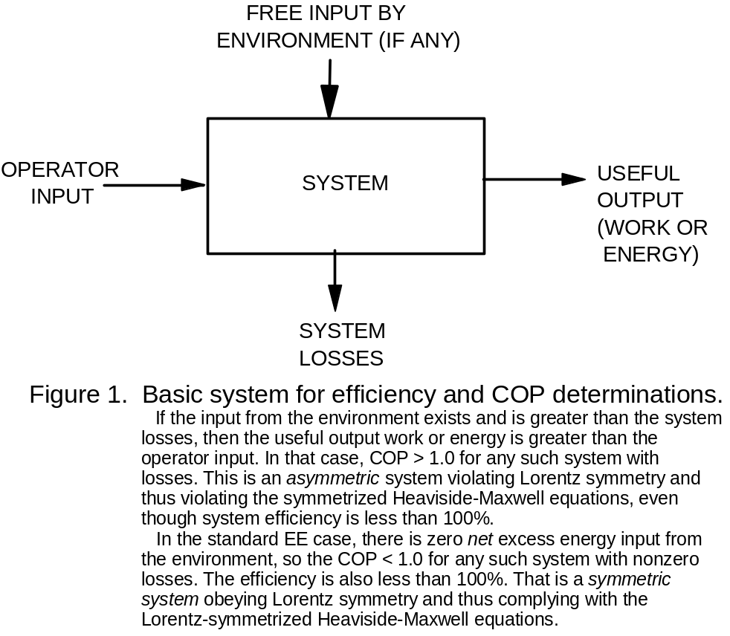
Compare this to the symmetrized system operation shown in Figure 2 below. In Figure 2, following Lorentz, the symmetrized CEM/EE model forcibly produces equal and opposite energy flows to (i) power the external circuit/system loads and losses, and (ii) kill the source dipole. That is what Lorentz’s symmetrization of the Heaviside-Maxwell equations requires. All EM systems are already powered by EM energy extracted directly from the seething vacuum via the proven broken symmetry {Error: Reference source not found} of the source dipole (opposite charges). As can be seen from Figures 1, 2, 3, and 4, the symmetrical circuits built by our electrical power engineers kill their own free EM energy flow from the vacuum (by killing their own source dipolarity) faster than they power their loads. Hence
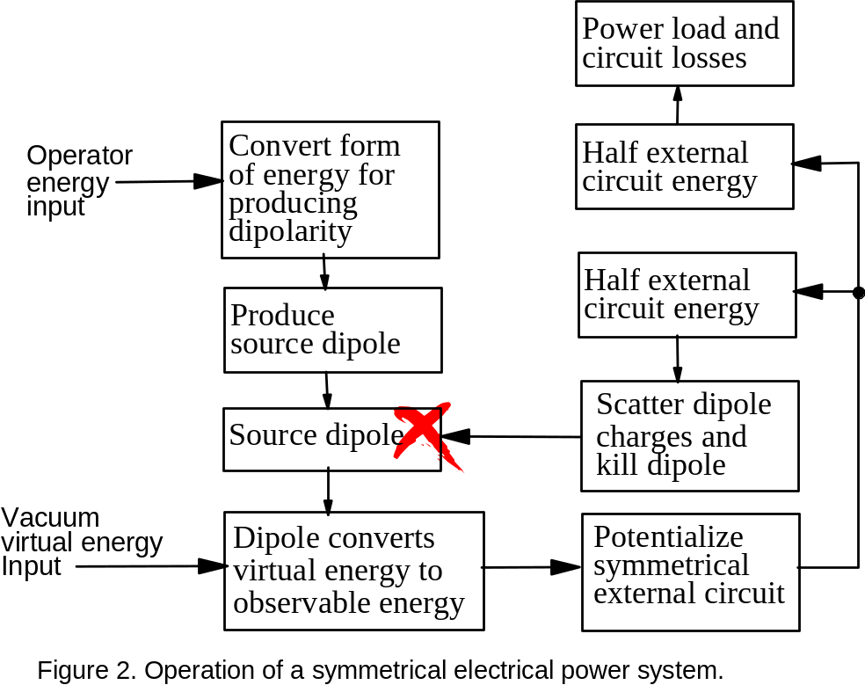
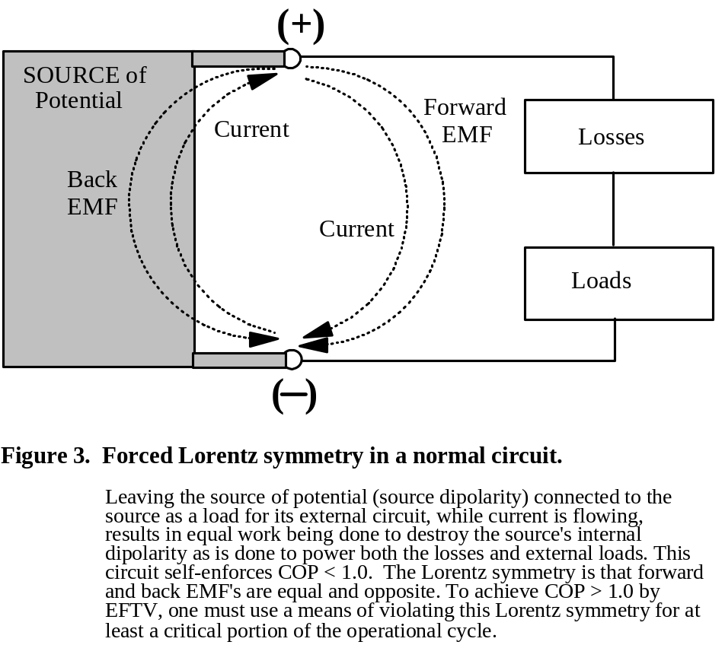
the operator continually has to “crank the shaft of the generator” to input more mechanical energy to remake the dipole. Figure 3 is thus another view of the symmetrized system, showing why forward and back emfs are equal and opposite. To achieve COP > 1.0, this situation must be violated. Figure 4 shows the six main operations of a typical electric power generator, consistent with Figures 2 and 3.
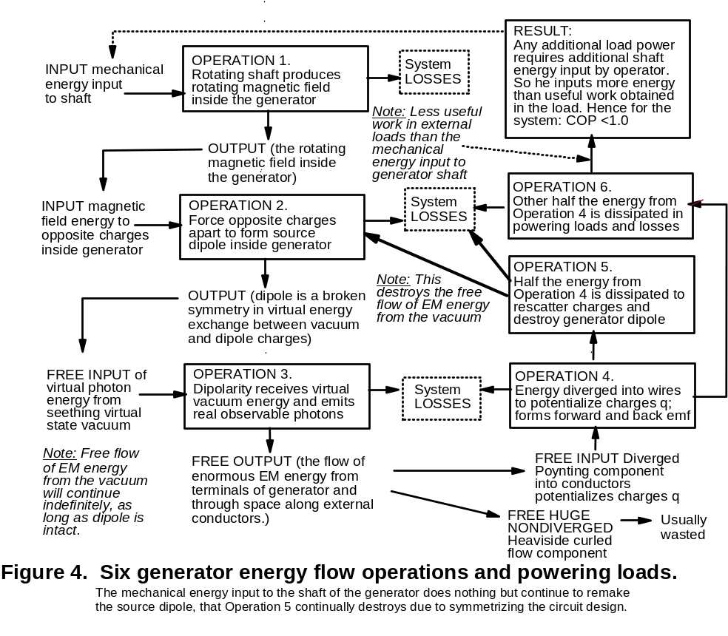
2.0 Regauging: Asymmetrical and Symmetrical.
“Regauging” essentially means changing the magnitude of one or more potentials. Change of a single potential is an asymmetrical regauging because it also changes the net force fields of the system (each regauging of one potential produces a new, free force field). Other things allowing, a net new free force field can freely drive additional electron current through the loads, thereby freely delivering some net useful work with the energy taken from the vacuum by asymmetric regauging. An asymmetric EM system – as shown in Figure 1 – inherently can allow COP > 1.0. The symmetrized EE model (as in Figures 2 and 3) eliminates all such COP > 1.0 EFTV systems.
Symmetrical regauging consists of two simultaneous asymmetrical regaugings, where both the scalar potential φ and vector potential A are changed. This of course produces two new free EM fields in the system, which wind up generating the equal and opposite emf’s shown in Figure 3. To be symmetrical, in electrical engineering the two potentials are deliberately and arbitrarily changed exactly such that the two new force fields are equal and opposite {}. For that reason, in a standard symmetrical EM system, the back emf and forward emf are equal but opposite in direction. In short, this is a way to see that the net emf of the system is zero. The circuit self-enforces that COP < 1.0 condition.
Hence symmetric regauging does not permit the net force field of the system to change, although the two opposing force fields (equal and opposite) change the system’s total potential energy from the vacuum. In fact, it changes the stress potential energy of the system, increasing the physical stress in the system. This stress potential dissipates equally in both directions (for the forward emf and the back emf), hence the “symmetry” of the regauging by halving the dissipation of the additional stress-potential energy.
The symmetrically regauged CEM/EE system cannot have any “extra net force field energy and drive” to freely power the loads alone. Its forward and back emfs are equal in magnitude but opposite in direction. Whatever the amount of energy dissipated by the symmetrized and potentialized system to furnish the “forward emf” and power the external circuit’s loads and losses, that same amount of potentialized energy is also dissipated in the other direction to furnish the “back emf” that destroys the source dipolarity inside the connected external source. It is the source dipolarity inside the generator that extracts usable EM energy from the vacuum, and furnishes the actual EM energy flow to the external circuit, powering the circuit (both loads and losses).
All EM systems are already “powered” by EM energy extracted from the energetic vacuum by the source dipolarity’s proven broken symmetry of opposite charges.
The six major operations in a generator provide its forcibly symmetrized operation as was diagrammed in Figure 4 above. Note that the back emf produces Action 5, and the forward emf produces Action 6. Mechanically cranking the shaft of the generator has nothing to do with the free extraction of EM energy from the vacuum by the source dipolarity inside the generator, and furnishing that energy to the external circuit to power the loads and losses. It only has to do with forcibly restoring the separation of opposite charges inside the generator – to restore the source dipole. The inane symmetric system keeps self-destroying its own source dipole faster than it powers its useful loads. The resulting restriction to COP < 1.0 performance of present symmetrized electrical power systems is due entirely to their inane design for self-enforcing Lorentz symmetry. It is not due to a law of nature, a law of physics, or a law of thermodynamics.
To apply a phrase borrowed from Tesla {}, operation 5 in Figure 4 – which forces the symmetrization of our electrical power circuits – represents “…one of the most remarkable and inexplicable aberrations of the scientific mind which has ever been recorded in history." Tesla himself was able to “shuttle” potential and potential energy around in his patented circuits with ease, as rigorously shown by Barrett {}. Barrett, who is one of the pioneers of ultrawideband radar, extended Tesla's method and obtained two related U.S. patents for use in signaling science and systems {}.
See again Figure 1. By using a freely created energetic change of external spacetime to include the presence there of a curl-free magnetic vector potential A, and obtaining a free extra asymmetric net input of E-field energy into the system from its altered space environment, then the thermodynamic behavior of this altered (asymmetric) system is analogous to that of a home heat pump {}. The variable theoretical maximum COP of a standard heat pump can be as high as 9.22. The usual home heat pump has an efficiency of only about 50% or less, so that at least half of all its energy input is lost. However, the heat pump extracts and receives so much additional free (or nearly free) heat energy from its external environment that it still outputs from 3 to 4 times as much heat energy as the electrical input energy paid for by the operator. So the heat pump’s actual COP is usually about COP = 3.0 to 4.0.
In short, in Figure 1 we have also included asymmetrical EM systems that are permitted to function analogously to a home heat pump. Such permissible EM systems have been arbitrarily excluded from the CEM/EE model (and from electrical power engineering) for more than a century, since Lorentz arbitrarily symmetrized the Heaviside-Maxwell equations in 1892, thus arbitrarily discarding all asymmetrical Maxwellian systems. Nature does not prohibit such asymmetrical COP > 1.0 EM systems, but classical electrodynamics and electrical engineering inexplicably still exclude them.
See Figure 5 below. An asymmetric EM power system with sufficient energy input from its environment can also be close-looped so that all its required energy input is provided by the environment, and the operator need input nothing. Usually the system is first run up to speed under load, and then the clamped switch-in of close-looping is accomplished.
This close-looped “self-powering” system is also included in Figure 1.
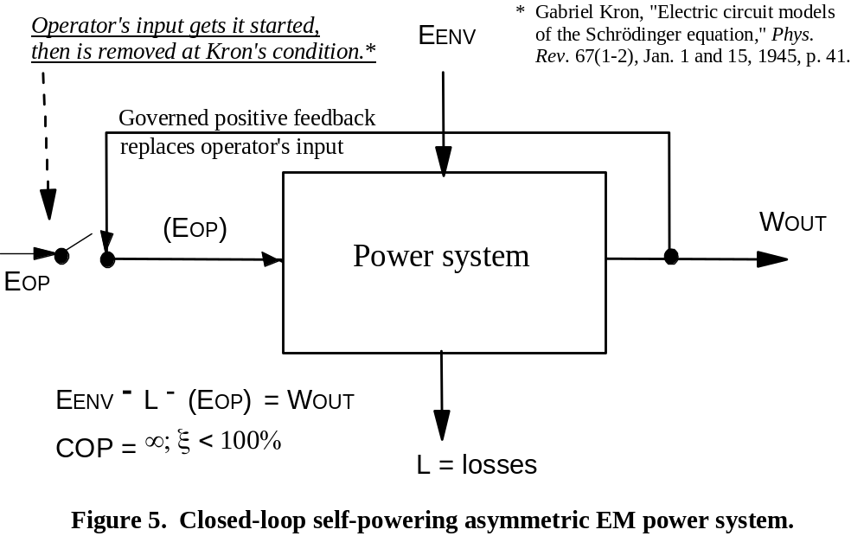

Quoting Goebel {}:
"[T]he zero of both scalar and vector electromagnetic potentials is irrelevant; the addition of a constant to an electromagnetic potential is of no consequence (so-called gauge invariance of the first kind)”
The well-known gauge freedom axiom assures that we can freely potentialize (regauge) either symmetrically or asymmetrically, if we design the system accordingly. The absolute magnitude of a potential is not measurable; only the difference in potential magnitude between two points can be determined and measured. So one can always add (and is free to add!) a curl-free A-potential to the curled vector potential A. In that case, the magnetic field will still come out the same (this is known as gauge invariance). This implies that a curl-free A-potential may always accompany the curled A-potential (the
B-field), but our instruments cannot directly measure that uncurled A-potential component. Its effects on moving charges, etc., however, can be measured and utilized.
This strongly supports the hypothesis that an uncurled A-potential can be said to always accompany the curled A-potential. We may consider “the” A-potential to have two components – one curled and the other uncurled. This implies the possibility for the Aharonov-Bohm effect, since the curled A-potential component (the B-field) can conceivably be localized while the uncurled component still spills beyond in the space outside the B-localization region. So we already have extra energy available with every A-potential, particularly if we “separate its two components and use them separately”.
3.0 Two Slit Quantum Interference Experiments with Electrons.
Figure 6 shows a typical two-slit experiment with electrons. As can be seen, the quantum aspects of the electron (due to the duality principle, it is both a wave and a particle and can act as either one!) leads to the symmetrical electron strike pattern shown on the observation surface or screen. A long solenoid coil is in the middle of the two slits, on the side after an electron has interacted with the two slits and is between the slit panel and the observation screen. In Figure 6, this coil is not energized and it has no current or magnetic field. Hence B = 0 inside and outside the coil, and the A-potential is zero.
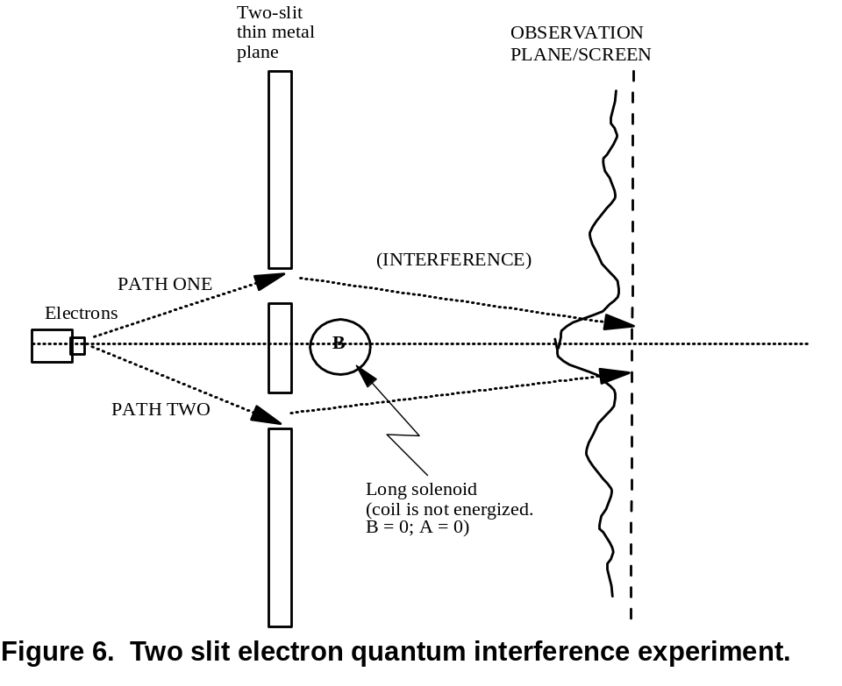
Figure 7 shows the same two-slit experiment with electrons, but now with the long solenoid energized. Inside the turns of the coil, there is now a B-field, but confined totally to the inside of the coil windings. Classically one would expect there to be no A-potential
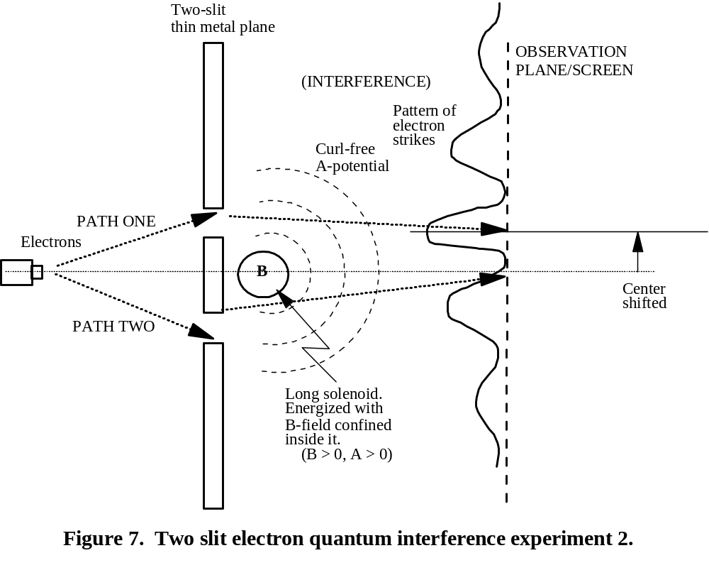
in space outside the coil, but that is not true. There is no curled A-potential in the external space, but there is an uncurled A-potential there. Hence the electrons passing through the two slits as “waves” are shifted in the “particle strike zones” on the detecting screen.
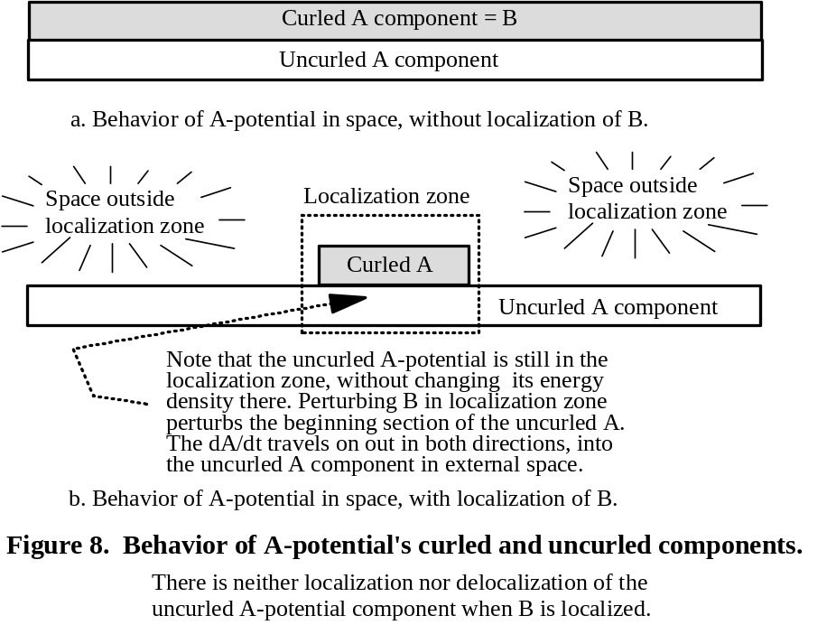
Figure 8 diagramatically shows our contention that, when the B-field is localized inside the coil, then the unlocalized curl-free A-potential is both inside the coil and in the space outside. In short, the curl-free A-potential component is both inside and outside the zone, and it is not localized to the inside as is the B-field (the curled A-potential component). Curl-free A is not excluded from the localization zone and is not restricted spatially.
When the B-localization occurs inside the core material of a toroidal transformer core that is the confinement zone for the B-field and B-flux, the uncurled A-potential is both inside and outside the core material localization zone while B is only inside.
When an input signal perturbation is then introduced to the input coil on the transformer “localization” core, the signal perturbs not only the confined B but also that section of the uncurled A-potential that is inside the localization zone. Hence the perturbation of the uncurled A-potential travels from inside the localization zone outward in all directions into the large remainder of the uncurled A-potential in space outside the core.
So the “A-potential” disturbance travels from inside the core out in all directions into space beyond it. According to Equation [3], when that external A-potential is perturbed, there arise E-field pulse energy disturbances that travel in the opposite direction – i.e., from the external space back into the core. The energy magnitudes of these returning input E-field pulses from the external environment are controlled by controlling the dA/dt rise time and decay time on the operator’s input pulses to the input coil.
This setup generates (i) an external excess EM energy reservoir that is the external curl-free A-potential, and (ii) the outgoing perturbation signal results in the external curl-free A-potential reservoir generating E-field energy pulses that travel from that external reservoir back into the coil or core. This generates excess free energy input from the environment as shown in Figure 1. So COP > 1.0 and self-powering are now permitted.
Figure 9 below shows a cross section view of the uncurled A-potential spilling out into external space outside the B-field confinement zone in a toroidal coil. When perturbed by a disturbance traveling from the toroid out into the external curl-free A-potential, energetic E-field pulses are generated in the external space and travel back into the localization zone. This converts the normal symmetrical system into an asymmetrical system in accord with Figure 1, permitting the operation shown in Figure 5.
Figure 10 below shows the cross section of the uncurled A-potential outside a toroidal coil, in a 3-dimensional representation, with the stimulated E-field pulses coming back.
As seen in Figures 9 and 10, the foregoing argument and the proven Aharonov-Bohm (AB) effect justify our statement that the AB effect can be used to obtain extra energy from the vacuum. As shown by Evans {}, consideration of excess EM energy freely received from the active vacuum will often involve the AB effect. Further, these AB effects and their extensions (and related effects) have now been widely found in physics, from individual atoms to nanocrystals to mesoscopic systems to macroscopic systems. Indeed, without fanfare a quickly growing initial technology of directly engineering the vacuum and its energy has been emerging, largely unnoticed for use in power systems.

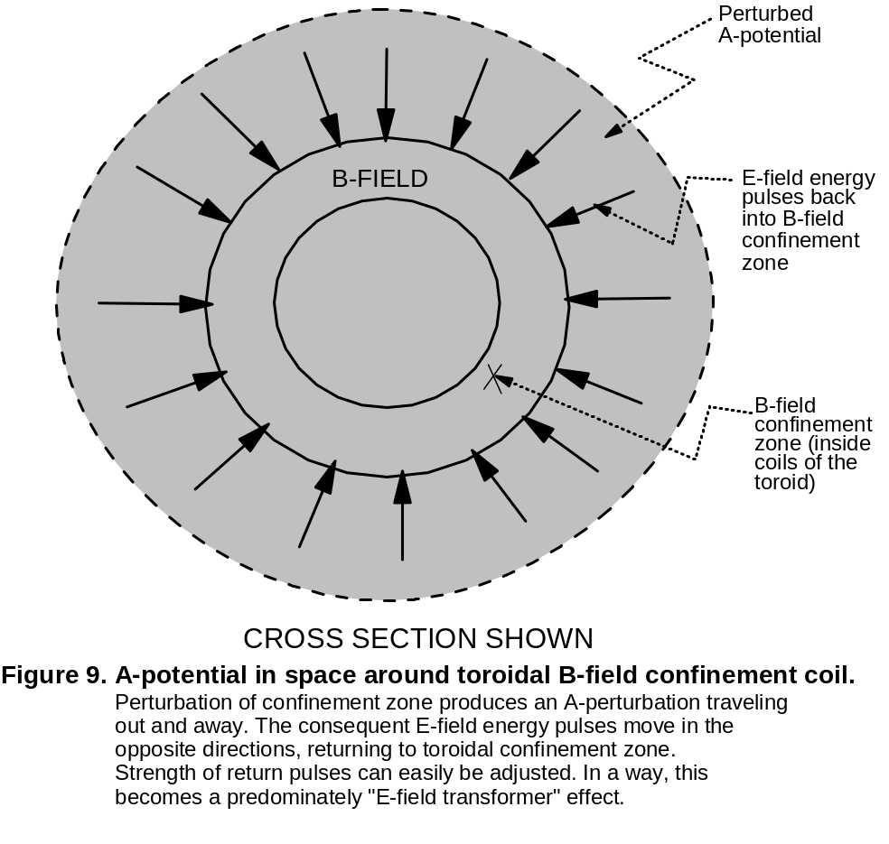
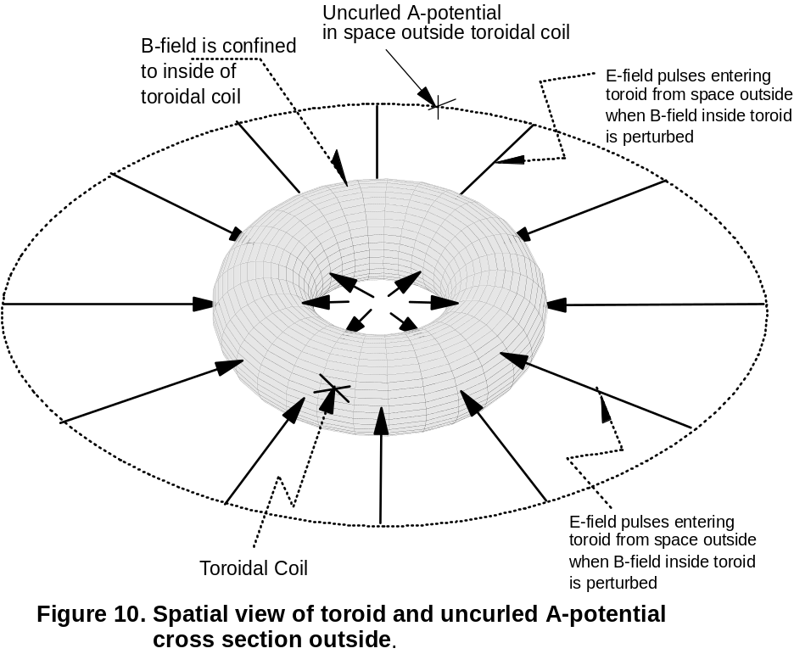
It does not require work and force to perturb an A-potential in space! In space alterations there are no forces or force fields, hence there is no spatial “force” or “power” or “work” a priori. EM force, power, and work only occur in – and as – the ongoing interaction with charged mass of the force-free field in space.
See again Figures 1, 3, and 5. Any system freely receiving usable excess EM energy from its environment is permitted to produce COP > 1.0 – e.g., as a solar cell array does. Indeed, if enough energy is freely received by the system from its outside environment, then with proper clamped feedback from output to input, the operator need input no additional energy himself, once the system is in stable operation with all energy input being furnished by the perturbed active environment. This is true for asymmetrical EM power systems, but it is not true for symmetrical EM power systems such as are prescribed in the CEM/EE model which excludes the asymmetrical systems.
4.0 Potentials Were Opposed Then Reinstated in Advanced EM.
The prevailing early belief that the potentials were not real was not Maxwell’s belief, but the belief of those who altered Maxwell’s theory after his death – namely Heaviside, Hertz, etc. Quoting Heaviside {}:
"…the question of the propagation of, not merely the electrical potential ψ but the vector potential A …when brought forward, proves to be one of a metaphysical nature … the electric force E and the magnetic force H … actually represent the state of the medium everywhere… Granting this, it is perfectly obvious that in any case of propagation, since it is the physical state that is propagated, it is E and H that are propagated."
Hertz held a similar opinion. Quoting {}:
"I may mention the predominance of the vector potential in [Maxwell's] fundamental equations. In the construction of the new theory the potential served as a scaffolding… it does not appear to me that any … advantage is attained by the introduction of the vector potential in the fundamental equations; furthermore, one would expect to find in these equations relations between physical magnitudes which are actually observed, and not between magnitudes which serve for calculations only."
These are two of the scientists who also severely truncated Maxwell’s theory into the four familiar vector equations of today. Maxwell’s actual theory was in quaternion and quaternion-like algebra, and consisted of 20 equations in 20 unknowns {}. Quoting Maxwell in his original theory:
"In order to bring these results within the power of symbolical calculation, I then express them in the form of the General Equations of the Electromagnetic Field. … There are twenty of these equations in all, involving twenty variable quantities."
Heaviside, Hertz, and others firmly believed that only force fields were real. Since they also believed firmly in the thin material ether filling all space, they assumed that mass was everywhere – at every point in the universe. And so (to them) there were force fields in “space” (more accurately, in the thin material ether thought to be filling all space). Indeed, Heaviside hated potentials and tried to get rid of them. He considered them to be humbug and stated that they should be “assassinated from the theory”.
Quoting Nahin {}, a biographer of Heaviside:
"In an 1893 letter to Oliver Lodge, Heaviside said of his own work that it represented the 'real and true Maxwell’ as Maxwell would have done it if he had not been humbugged by his vector and scalar potentials."
Heaviside also hated quaternion algebra with the same fervor, and was one of the
co-creators of the much more limited vector algebra.
Ironically, Heaviside eventually had his way. It is Heaviside’s truncated equations and notions, as further truncated by Lorentz symmetrization and his discard of the giant nondiverged Heaviside energy flow component, that are erroneously taught today as “Maxwell’s theory”. Lorentz’s truncation arbitrarily discarded all asymmetrical Maxwellian systems, and retained only symmetrical Maxwellian systems. This is the mutilated standard classical electrodynamics and electrical engineering model taught in all our universities, and used to design and build all our electrical power systems.
With the march of physics into such new discoveries as special and general relativity, quantum mechanics and then particularly with the appearance of quantum electrodynamics, the view of modern physicists with regards to EM theory and systems dramatically changed. Now it was known that the potentials (A and φ) were primary, and the fields were only changes imposed on those primary potentials. Quoting Nobelist Feynman {}, one of the co-founders of quantum electrodynamics:
"In the general theory of quantum electrodynamics, one takes the vector and scalar potentials as the fundamental quantities in a set of equations that replace the Maxwell equations: E and B are slowly disappearing from the modern expression of physical laws; they are being replaced by A and φ."
5.0. CEM/EE Was Frozen Prior to Most of the Discoveries of Modern Physics.
To recap: The hoary old classical electromagnetics and electrical engineering (CEM/EE) model was put together back in the 1880s and severely curtailed. Then it was further limited (symmetrized) by Lorentz in the 1890s and “frozen” shortly thereafter. It has remained frozen since then, even though many of its foundations assumptions are now known to be false {}.
The “freezing” of the CEM/EE model into an iron dogma occurred decades before the advanced EM discoveries of most of modern physics. There was no special or general relativity, quantum mechanics, quantum electrodynamics, quantum field theory, gauge field theory, etc. Since then, eminent scientists such as Feynman, Wheeler, Margenau, Bunge and others have pointed out the falsities in that old model – but the scientific community still adamantly refuses to correct these CEM/EE errors and falsities long since shown by the march of physics.
But if (i) the potentials are real and fundamental, and (ii) a field is only a change in a potential, then obviously A and φ can exist as field-free (unchanging) potentials. A thing need not change to exist! The field-free potential is a constant potential with no dynamic changes imposed upon it or upon a fraction of it. So the magnetic vector potential A can exist with no associated B-field (no curled component of change associated with it), in which case it is referred to as the “curl-free” or uncurled A potential, or as the “field-free” potential. Whenever the A-potential is steady and has no changes at all (no curl or time-rate of change, etc), then it is a field-free potential. In that case, the resulting uncurled magnetic vector potential A (where the B-field or curl component has been removed) can become a free EM entity of nature – with its own potential energy and potential energy density – that alters the energy density of spacetime and curves it, also changing the virtual particle flux density of the local vacuum.
6.0 There Are No EM Force Fields in Space.
The old material ether justifying the notion of a force field in space was falsified in 1887 by the Michelson-Morley experiments {}. Since mass is a component of force by the equation F ≡ d/dt(mv), the experiments effectively destroyed all forces and force fields in mass-free space. All EM fields and potentials in space are now known to be mass-free and thus force-free, since – observably – space is massless. Force fields exist only in matter and matter systems, not in mass-free space. For the EM force field, charged mass (an electrical charge called q or a magnetic charge called a “pole”) is one of its necessary components.
The potential in space and the field in space actually exist only as “conditions in and of massless space”, as pointed out by Feynman in his 1964 three volumes of sophomore physics. Quoting Feynman {}:
"…the existence of the positive charge, in some sense, distorts, or creates a ‘condition’ in space, so that when we put the negative charge in, it feels a force. This potentiality for producing a force is called an electric field."
Quoting Feynman {} again:
"We may think of E(x, y, z, t) and B(x, y, z, t) as giving the forces that would be experienced at the time t by a charge located at (x, y, z), with the condition that placing the charge there did not disturb the positions or motion of all the other charges responsible for the fields."
In other words, no EM force field exists until the force-free field in space is in an ongoing interaction with charged mass q. Both charged mass and force-free EM fields, interacting, define “what an EM force is”. A “field in space” only has the capability to produce a force field in charged matter, if it should happen to meet some charged matter q and interact with it. And that is a free capability. Simply producing the static force field itself in charged matter, requires no “work”! If the matter then moves, so that ∫ F⋅ds > 0, then that produces work.
Jackson, an eminent classical electrodynamicist, at least admits that the “force fields in space” used by classical electrodynamicists are assumptions by them, and that an observable force field actually requires observable charge. Quoting Jackson {}:
"Most classical electrodynamicists continue to adhere to the notion that the EM force field exists as such in the vacuum, but do admit that physically measurable quantities such as force somehow involve the product of charge and field."
Consider the simple equation F = Eq. Here the ongoing interaction of E and q (signified by their product) produces force F, on charge q which is a component of F. In mass-free space, q = 0. For an E-field in mass free space, E > 0 yet q = 0. In that case, F = 0, and the E-field existing in massless space is seen to be force-free. Note that electrical engineering is in total violation of this simple fact, as admitted by Jackson {Error: Reference source not found}.
7.0 Forming and Using an Energy Reservoir in Altered Spacetime.
The field-free A-potential has energy density and occupies space (it is a condition of space itself!), changing the energy density of that spatial region. Hence the space it occupies and is part of has been relativistically altered in terms of spacetime curvature or distortion – and the energy density of that space has been changed. That space is curved or distorted, and it is no longer flat. This does not appear at all in CEM/EE, since that model erroneously assumes that spacetime is flat and the vacuum is inert. In short, the standard EE power engineering science arbitrarily excludes forming a usable EM energy EFTV reservoir in space, and forbids EM systems accepting and using free input EM energy from such. Hence it obviously excludes the Aharonov-Bohm effect a priori.
From equation [3] above, the gradient of the electrostatic scalar potential φ is an E-field, and the time-rate of change of the magnetic vector potential is also an E-field. In space, these two E-fields are force-free and are not the common “force E-fields in space” that the CEM/EE model erroneously assumes. It is only the ongoing interaction of a force-free E-field with charged mass q that constitutes an ongoing force E-field in that charged-matter q system.
But this is very interesting. See again Figure 8, and consider the confined B-field zone before perturbing whatever is in that zone. The constant A-potential is devoid of any change in it (i.e., specifically from the associated B-field change or curl in it). A constant A-potential always exists with and “underneath” its curled (swirling) component B. When the change component (the B-field) is confined to the localization zone, the constant uncurled A-potential component underlying it is not affected. This uncurled A-potential is present in the confinement zone and in the space outside it. Hence in space outside the B-field localization zone, there now appears that uncovered field-free magnetic vector potential A component! So all the B-field energy is still in the confinement zone, and outside it there is additional curl-free A-potential energy.
Note that when we perturb that B-field in that localization zone, we also perturb the “inside” portion of that constant A-potential extending on out into space beyond the zone. We create a perturbation signal in that uncurled A-potential, traveling in all directions from its “beginning” inside the localization zone on out into its main body (energy reservoir) in the space outside and beyond.
By localizing the curled A-component (localizing the B-field change component and holding it in a specific volume), as shown in Figures 8, 9, and 10, then outside that localized B-field confinement area there appears an “uncovered” curl-free magnetic vector potential A. That represents a change to the EM energy density of the spacetime outside the localization region, and so that outer spacetime now has extra EM energy from which appreciable E-field energy can be extracted easily by mere perturbation.
Again, perturbing a force-free potential or a force-free field in space does not involve force, power, or work. So the force-free perturbation can be work-free, generated by the perturbation of the input signal to the input coil of a standard transformer whose nanocrystalline core freely and automatically localizes the B-field.
By B-localization, the uncovered uncurled A-potential component itself can be spatially brought out from its (usually) covering B-field (curled A-potential component) in the nonlocalized region outside the B-field localization zone. The uncovered curl-free
A-potential outside the localization zone will have a zero B-field change component, since the B-field curled component is held firmly in the localization zone.Error: Reference source not found
If we can freely localize the B-field (the curled component of the magnetic vector potential A) in a restrained small volume or spatial region, then outside that small volume there must be an uncovered uncurled A-potential component freely appearing and remaining. This special free external A-potential energy reservoir can easily be engineered to input extra E-field energy to the system, for free. The external A-potential energy source is a real EM energy reservoir now easily tapped by the system.
We will shortly cite references to show there are many different materials and constructions that freely invoke the Aharonov-Bohm effect or its related variants.
8.0 Background of the Aharonov-Bohm Effect.
An energized toroidal coil or long solenoid will confine the curled A-component (the
B-field) inside its coils. In the space outside the coils, there then appears that remaining uncurled A-potential as an altered condition of that external space. And that extra energy density that has now appeared in the outside curved spacetime, also changes the virtual particle flux of the vacuum outside the B-field localization region. An electron two-slit experiment in that altered spacetime region outside the toroidal coil will generate a phase shift of the electron’s quantum interference as it passes through the two slits.
The earliest prediction of the AB-type effect was by Ehrenberg and Siday {} in 1949. This was an earlier prediction of the later Aharonov-Bohm effect {}, duly recognized and cited by Aharonov and Bohm in their second paper {}.
By considering the phase shift of an electron moving through that external uncurled
A-potential in a two-slit type experiment, Aharonov and Bohm published their first work in 1959 in the leading U.S. physics journal {Error: Reference source not found}.
In 1960, shortly after the 1959 publication by Aharonov and Bohm, Chambers {} experimentally demonstrated the Aharonov-Bohm effect. Many other successful experiments were performed over the next two decades, but the rigorous experimental “absolute clincher” was given by A. Tonomura et al. {, }. Dr. Tonomura is presently a member of the Science Council of Japan and a Fellow of Hitachi, Ltd.
A good popularized science article on this effect was given by Imry and Webb {} in 1989. In the same year Peshkin and Tonomura {} coauthored a major book on the effect. In 1999 Akira Tonomura received the Franklin Institute Award for his work.
The effect has also been observed in carbon nanotubes {}.
After a new subject is firmly established in physics, several leading physics journals publish extensive reviews and summaries of the new area. For a summary publication two decades ago that lists hundreds of pertinent physics references and experiments on the Aharonov-Bohm effect even then, see Olariu and Popescu {}.
A decisive statement of the metal-ring situation was also given for the educated layman by Schwarzschild {}. These ring experiments confirmed that the Aharonov-Bohm effect had been rigorously proven to the satisfaction of all but the most diehard skeptics. Today, with thousands of confirming papers and experiments in the literature, any technical person posturing that there is no curl-free A-potential or Aharonov-Bohm effect is akin to those who still believe the earth is flat and that sailing ships will fall off the planet if they sail over the edge!
To extract excess EM energy from the vacuum, one has to electromagnetically perform direct EM engineering of the vacuum itself. Since a potential is merely altered spacetime/vacuum, engineering the appearance of a potential in the surrounding vacuum is directly engineering the vacuum itself, originally foreseen by Nobelist Lee. Quoting Lee {}:
"The experimental method to alter the properties of the vacuum may be called vacuum engineering… If indeed we are able to alter the vacuum, then we may encounter some new phenomena, totally unexpected."
Systems producing the Aharonov-Bohm (AB) and other phase effects are found widely and routinely today in physics, and these systems are asymmetric EM systems not describable by the classical EM and electrical engineering model which permits only symmetrical EM systems. E.g., Nazarov {} showed the AB effect in two tunnel diode junctions. This means that, if one finds and builds the proper asymmetric circuitry using the Aharonov-Bohm effect generated by two such tunnel diodes, then one can build an asymmetric circuit not predicted at all by the CEM/EE model and theory. Using the Aharonov-Bohm effect, such an asymmetric system has curved its local spacetime outside the system’s B-field localization region. Perturbation of that curl-free A-potential in the “outside” space produces real E-field energy pulses that move back into the localization zone (system). With proper control and phasing, this feed-back energy input to the localization system – of excess free EM perturbation energy from the surrounding curved spacetime – produces an asymmetric Maxwellian system permitted to have a thermodynamic coefficient of performance of COP > 1.0.
But COP > 1.0 Maxwellian systems are permitted in only that vast class of asymmetric Maxwell systems so arbitrarily discarded by Lorentz and still arbitrarily discarded by modern CEM/EE – and by all our electrical engineering departments, professors, textbooks, and power engineers. What is so sadly missing from the present horribly archaic CEM/EE model are the direct statements and explanations of the equations and operations as (i) EM engineering of the active vacuum/spacetime, and (ii) then the ongoing interaction of the engineered vacuum/spacetime with the charged mass system.
The tunnel diode system producing the AB effect is of particular significance when considering – and searching for – the AB effect in crystalline materials, and particularly in nanocrystalline materials as used in the motionless electromagnetic generator (MEG).
9.0 Extension of the Aharonov-Bohm Effect.
In 1984 Michael Berry {} further generalized and extended the Aharonov-Bohm effect to what is called the “Berry Phase”. Many background papers are available at Berry’s website http://www.phy.bris.ac.uk/people/berry_mv/publications.html .
Of particular interest is the demonstration by Berry and Klein {} that stacks of crystal plates can and will indeed produce such “quantum phase” effects. Together with Nazarov’s work cited above {Error: Reference source not found}, this indicates that in unusual packing of very fine crystals in layers – such as in a modern nanocrystalline layered transformer core – perhaps one may find that some core variants and arrangements produce the Aharonov-Bohm effect “for free” as a special functioning of the materials themselves.
That is what we have found in the motionless electromagnetic generator (MEG).
In that case, the free action of the materials and construction of the transformer core can have an extra free input of curl-free A-potential perturbation energy back into the localizing transformer core as E-field energy pulses, via the simple equation dA/dt = − E. In short, we have added one characteristic – that of direct engineering of the local vacuum “for free” – to the listing by Kondepudi and Prigogine {} of characteristics of materials that allow violation of the second law of thermodynamics. This extra “free” EM energy input to the system from surrounding altered and energetic spacetime, constitutes the functioning of an asymmetric Maxwellian system violating the present symmetrized electrical engineering model. It directly permits COP > 1.0 operation once the feedback process is elicited and well controlled. So it permits violating the second law of near-equilibrium thermodynamics.
In the motionless electromagnetic generator (MEG), this was the case. Certain off-the-shelf nanocrystalline transformer cores in layered construction did indeed localize the
B-field inside the core, and thus freely induced the Aharonov-Bohm effect wherein the uncurled A-potential also appeared in the immediately surrounding space outside the core. Operational principles used in the motionless electromagnetic generator have previously been given by the present author {, , , , }.
10.0 Violating the Second Law of Thermodynamics.
For permissible COP > 1.0 EFTV EM systems, we thus seek asymmetric EM systems that violate the second law of thermodynamics or allow such violation. Indeed, various asymmetries are already recognized in nonequilibrium thermodynamics to allow violation of the thermodynamics second law, as verified by Kondepudi and Prigogine {Error: Reference source not found}. One such area is strong gradients (as used on the leading and trailing edges of the input energy pulses in the MEG) and another is memory characteristic of materials (as also used in the MEG in the nanocrystalline core materials and structure that freely localize the B-field and thus evoke the Aharonov-Bohm effect). These known, recognized mechanisms allow macroscopic and significant thermodynamic violations of the Second Law that are directly usable by real systems such as the MEG.
Maxwell – who was also a noted thermodynamicist –pointed out that real systems are continually violating the hoary old second law anyway. Quoting Maxwell {}:
"The truth of the second law is … a statistical, not a mathematical, truth, for it depends on the fact that the bodies we deal with consist of millions of molecules… Hence the second law of thermodynamics is continually being violated, and that to a considerable extent, in any sufficiently small group of molecules belonging to a real body."
Wheeler already clearly pointed out that mass and space continually interact. Quoting Wheeler {}:
"Space acts on matter, telling it how to move. In turn, matter reacts back on space, telling it how to curve."
Used to directly engineer active spacetime/vacuum, the importance of these quantum phase effects further increases, and they were even further extended. Aharonov and Anandan {} again further generalized the Berry phase into what is known as the geometric phase.
In modern physics today a vast range of valid “quantum phase related” EM effects that engineer the vacuum and totally violate electrical engineering are known. Indeed, the literature now contains some 20,000 papers dealing with the Aharonov-Bohm effect, Berry phase, geometric phase, and related quantum interference areas, with more experiments and papers being added every year. Thousands of theorists and experimentalists have verified the effects both experimentally and theoretically, and they are continuing to discover new related effects as well.
Any person trained only in CEM/EE who proclaims that all these scientists and experiments are false – and that the A-potential and such effects do not even exist, or that vacuum engineering by EM methods is impossible – is still very much in the ostrich position, with his head and eyes buried firmly in the sand.
We again point out that such an asymmetric effect as the Aharonov-Bohm effect is specifically excluded by the horribly crippled old CEM/EE model used in standard electrical engineering – which allows only symmetrical systems. In 1892 Lorentz {, } arbitrarily symmetrized the Heaviside theory (a highly curtailed version of Maxwell’s theory) just to obtain simpler equations easier to solve algebraically, thus reducing the need for use of numerical methods. He thereby arbitrarily discarded all of nature’s asymmetrical Maxwellian systems, such as those producing the Aharonov-Bohm effect, the Berry phase, and the geometric phase. And he also discarded (arbitrarily) all Maxwellian systems that can accept and use excess EM energy from the active vacuum, since any such system is an asymmetric Maxwellian system a priori. In the flawed old CEM/EE model, the vacuum is assumed to be inert and spacetime is assumed to be flat.
11.0 Aharonov-Bohm Effect and the Motionless Electromagnetic Generator.
Figure 11 shows a motionless electromagnetic generator (MEG) laboratory proof-of-principle prototype. It is a highly asymmetrical EM system. The Aharonov-Bohm effect turns out to be central in the (MEG) {}, which is a general relativistic system directly engineering its own curved spacetime and energetic vacuum a priori.
To accept and use excess energy from the vacuum, the system must be an asymmetrical system that deliberately violates Lorentz symmetry {}. Many conventional electrical

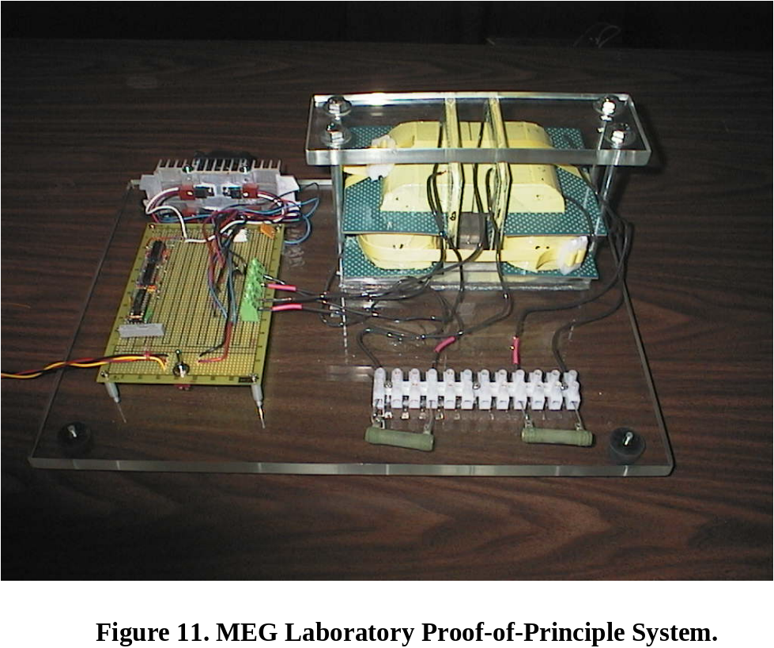

engineers – particularly those who attempt to dominate the thinking of the struggling “energy from the vacuum” community – presently try to dictate that such overunity systems are doable in compliance with the CEM/EE model, or else they are “fakes” and “hoaxes”. In that respect, such engineers are part of the vacuum energy problem rather than part of the solution! They simply have not understood that violating electrical engineering model and circuitry is the first requirement for EFTV COP > 1.0 electrical power systems.
Quoting Evans and Jeffers {}:
"…the Aharonov-Bohm effect is a local gauge transformation of the true vacuum…[which] produces a vector potential from the true vacuum. [This gauge transformation] produces topological charge…, the electromagnetic field, which carries energy, and the vacuum charge current density first proposed by Lehnert … and developed by Lehnert and Roy…"
Electrical engineers design and build only symmetrical electrical power systems. They have absolutely no experience in nature’s asymmetric Maxwellian electrical power systems so long erroneously discarded by Lorentz and the electrical engineering profession. They totally do not comprehend that all the fuel consumed, wind used, and water current used in their electrical power systems have nothing at all to do with furnishing the Poynting energy flow onto the external circuit to power it, and that all that consumption of fuel and other resources has only to do with continually remaking the source dipolarity in their generators, that their symmetrized systems destroy faster than they power their loads.
We pay the power companies to deliberately engage in a giant wrestling match inside their generators and always lose.
The terribly flawed and symmetrized electrical engineering model, taught in all our EE departments and texts and in our universities, cannot and does not contain the Aharonov-Bohm effect, the Berry phase, or the geometric phase (GP) effects. It cannot and does not overtly spell out that it involves direct engineering of the active vacuum/spacetime, under the guise of engineering “potentials” and “fields” erroneously assumed to be separate from the active spacetime/vacuum. All the Aharonov-Bohm, Berry, and GP systems are asymmetrical EM systems a priori, permanently excluded – as are EFTV COP > 1.0 systems – by Lorentz and by present EE departments, professors, and texts. It is already the flawed electrical power engineering – and the continued tolerance and propagation of it by our scientific community – that are directly responsible for humanity not having long-ago developed and deployed such asymmetrical electrical power systems, fuel-free and taking their required input energy from the vacuum.
12.0 Aharonov-Bohm Effect and Energy from the Vacuum.
In modern physics the magnetic vector potential A is absolutely required and well-known. Modern electrodynamics (such as quantum electrodynamics, gauge field theory, Yang-Mills theory, etc.) recognize the potentials as the primary realities, and the fields as just changes in the more primary potentials. Modern electromagnetic physics is not just a simple Lorentz-symmetrized classical EM concept! Instead, to deal with EM systems that are asymmetric and therefore permitted to extract and use excess EM energy from the active vacuum, one must have as general an appreciation as possible for the A-potential and its importance.
As an example, see the pertinent discussion by Evans, Labounsky, and Bearden {}. The abstract is quoted as follows:
“The most general form of the vector potential is deduced in curved spacetime using general relativity. It is shown that the longitudinal and timelike components of the vector potential exist in general and are richly structured. Electromagnetic energy from the vacuum is given by the quaternion valued canonical energy-momentum. It is argued that a dipole intercepts such energy and uses it for the generation of electromotive force. Whittaker's U(1) decomposition of the scalar potential applied to the potential between the poles of a dipole, shows that the dipole continuously receives electromagnetic energy from the complex plane and emits it in real space. The known broken 3-symmetry of the dipole results in a relaxation from 3-flow symmetry to 4-flow symmetry. Considered with its clustering virtual charges of opposite sign, an isolated charge becomes a set of composite dipoles, each having a potential between its poles that, in U(1) electrodynamics, is composed of the Whittaker structure and dynamics. Thus the source charge continuously emits energy in all directions in 3-space while obeying 4-space energy conservation. This resolves the long vexing problem of the association of the “source” charge and its fields and potentials. In initiating 4-flow symmetry while breaking 3-flow symmetry, the charge, as a set of dipoles, initiates a reordering of a fraction of the surrounding vacuum energy, with the reordering spreading in all directions at the speed of light and involving canonical determinism between time currents and spacial energy currents. This constitutes a giant, spreading negentropy which continues as long as the dipole (or charge) is intact. Some implications of this previously unsuspected giant negentropy are pointed out for the Poynting energy flow theory, and as to how electrical circuits and loads are powered.”
At any rate, soon after publication of the Aharonov-Bohm paper {Error: Reference source not found} in 1959, experiments showed that, if the magnetic field B is introduced but trapped inside a long solenoid, a phase shift is induced in the electron strike pattern of a two-slit electron experiment (Figure 7), even though no contact of the enclosed magnetic field and the moving electrons occurs. This phase shift is explained by the fact that the freed uncurled A-potential component exists outside the trapping solenoid or region, even though the
B-field (the curled A-potential component) does not. Consequently, interaction (perturbation) of this free uncurled A-potential with the electrons produces a phase shift of the QM interference detection pattern. That of course is a small effect, on one electron at a time.
The return effect need not be small, when a large region of the local vacuum is deliberately engineered! Work-free perturbation of the curl-free A-potential in the space outside the B-localization region produces strong E-field energy pulses that arise in that external altered outside space and are directed back into the B-localization system (as in the MEG, e.g.). The effect is easily demonstrated and proven experimentally.
This proves that the uncurled field-free magnetic vector potential is real and causes physical effects – even powerful effects – when perturbed. It is vacuum engineering.
13.0 Typical Patents Using Uncurled A-Potential.
There are in fact a number of patents dealing with the curl-free magnetic vector potential. For a few examples, see the several patents by Raymond C. Gelinas (these are assigned to Honeywell). The curl-free magnetic vector potential may in fact be used for direct transmission of communications. These patents are:
(1) Gelinas, Raymond C., "Apparatus and Method for Determination of a Receiving Device Relative to a Transmitting Device Utilizing a Curl-Free Magnetic Vector Potential Field." U.S. Patent No. 4,447,779, May 8, 1984.
(2) Gelinas, Raymond C., "Apparatus and Method for Modulation of a Curl-Free Magnetic Vector Potential Field." U.S. Patent No. 4,429,288, Jan. 31, 1984.
(3) Gelinas, Raymond C., "Apparatus and Method for Demodulation of a Modulated Curl-Free Magnetic Vector Potential." U.S. Patent No. 4,429,280, Jan 31, 1984.
(4) Gelinas, Raymond C., “Josephson Junction Interferometer Device for detection of Curl-Free Magnetic Vector Potential field.” U.S. Patent No. 4, 491,795, 1 Jan 1985.
(6) Gelinas, Raymond C., “Apparatus and Method for Distance Determination between Receiving Device and Transmitting Device utilizing a Curl-Free Magnetic Vector Potential Field.” U.S. Patent No. 4,605,897, 12 Aug 1986.
(7) Gelinas, Raymond C., "Apparatus and Method for Transfer of Information by Means of a Curl-Free Magnetic Vector Potential Field." U.S. Patent No. 4,432,098, Feb.14, 1984.
The latter patent is synopsized as follows:
“A system for transmission of information using a curl-free magnetic vector potential radiation field. The system includes current-carrying apparatus for generating a magnetic vector potential field with a curl-free component coupled to apparatus for modulating the current applied to the field generating apparatus. Receiving apparatus includes a detector with observable properties that vary with the application of an applied curl-free magnetic vector potential field. Analyzing apparatus for determining the information content of modulation imposed on the curl-free vector potential field can be established in materials that are not capable of transmitting more common electromagnetic radiation.”
To show an example of the increasingly widespread use of the effect, see Kazuhito Fujii “Quantum Interference Device and Method for Processing Electron Waves Utilizing Real Space Transfer,” U. S. Patent No. 5157467, Oct. 20, 1992. The abstract is as follows:
“A quantum interference device includes a source, a drain and waveguides with quantum structures between the source and the drain. An electron wave from the source that is confined in the waveguides is split into plural electron waves. The phase difference between the split electron waves is controlled and the split electron waves are combined into a single electron wave. The combined electron wave is directed to the drain or out of the waveguides according to an energy state of the combined electron wave by a real space transfer such as a tunneling effect. The phase difference control may be achieved by varying an electric field, a magnetic field, or light.”
Dr. Tonomura, who rigorously validated the Aharonov-Bohm effect to settle the issue once and for all {Error: Reference source not found}, also holds some 30 patents in Japan, some of which depend on the Aharonov-Bohm effect. Dr. Tonomura is a noted Japanese scientist with many awards. He is a Hitachi Fellow and a member of the Science Council of Japan.
As a final example, the U.S. Patent Office recognizes Class 257, subclass E21.089, Multistep processes for manufacture of device using quantum interference effect, e.g., electrostatic Aharonov-Bohm effect (EPO).
14.0 Conclusions.
14.1 All potentials are special aspects of the master potential of the seething virtual state vacuum. This includes all EM potentials and thus includes each EM field as a particular type of change or dynamics in a parent EM potential.
14.2 All EM potentials and fields in empty space are force-free. Further, the transverse force-field EM wave presently assumed in space actually exists only in charged matter, a priori. In space, the EM wave occurs as sets of more fundamental force-free longitudinal EM waves, as shown by Whittaker {, }.
14.3 Vacuum engineering – i.e., patterning, changing, and using particular aspects of the vacuum potential to then interact with matter and produce desired effects – is possible electromagnetically by a variety of ways and mechanisms.
14.4 Such vacuum engineering is effective and usable only in those asymmetric Maxwellian systems that were arbitrarily discarded by Lorentz prior to 1900, and still arbitrarily discarded today in the standard CEM/EE model.
14.5 Asymmetric Maxwellian systems, such as those properly using asymmetric effects such as the Aharonov-Bohm effect and its derivatives, can be utilized to extract free and usable EM energy directly from the vacuum via the local (decentralized) system. Indeed, all present EM systems already extract their EM energy directly and freely from the vacuum interaction of the source charges and dipoles.
14.6 Present electrical power engineering using only symmetrical systems continually destroys the source dipolarity and the free flow of usable EM energy from the vacuum. Hence the inane combustion of fuel, nuclear fuel rods, or wind input, water current input, and solar energy input in order to continue to remake the source dipolarity that the symmetric system continually destroys.
14.7 There is an urgent need for the scientific community to quickly correct and extend the CEM/EE model used in electrical engineering, and apply and teach a more comprehensive “supermodel” in all universities. A new technology of free “energy from the vacuum” EM systems is in the offing.
14.8 Unless there is rather immediate and strong action to dramatically correct and update the sad old EE model, and to use the new model in developing asymmetric COP > 1.0 power systems and self-powering systems, the probability of a catastrophic economic collapse of the United States and the Western world is in the offing.
14.9 Only by using vacuum engineering for electrical power systems that dramatically decrease our dependence on oil, coal, gas, and nuclear power can our economic collapse – and the possible collapse of Western civilization – be avoided.

References

Any EM field or potential – including the “static” ones – mathematically decomposes into sets of ongoing longitudinal EM wave energy flows, as shown by E. T. Whittaker in 1903 and 1904.
E.g., as in the free evocation of the Aharonov-Bohm effect by special materials and constructions.
In 1957 Lee and Yang received the Nobel Prize for their prediction of broken symmetry, including that of opposite charges and therefore of any source dipolarity.
Work rigorously is the change of form of energy. It is not the change of magnitude of energy in a given form – which is merely asymmetrical regauging and is work-free. Power, of course, is the time rate of doing work – i.e., it is the time-rate of changing the form of energy. It is not the time rate of changing the magnitude only of some energy remaining in a given form.
Hence all our electrical power systems have been and are symmetrical systems having COP < 1.0.
As Einstein noted, this did not destroy a nonmaterial ether, but only falsified an ether that was observably material.
Again, “potential” and “condition of space” are one and the same thing. Space is merely potential and potentials, and “a potential” in an EM system is just an alteration of the system’s local space (local space potential). The “fields” in the EM system are just additional changes in those “alterations of local space”.
The long solenoid or toroidal coil requires operator energy input, with current and voltage, to provide the extra curl-free A-potential energy reservoir in the external environment. Our goal (which has been realized) is to provide such an external energy reservoir freely, without the operator “paying” for it.
An easy way to show this localization is to place a strong straight bar permanent magnet in the inside air space of the transformer, across its open diameter. Air gaps at the contact ends should be absolutely minimized. For a core exhibiting the AB effect, almost the entire magnetic field B of the magnet is drawn into the localization area and no longer spills out into space around the bar magnet! A good magnetic field meter with excellent probe, placed directly against the surface of the magnet over one of its poles, will show almost zero “spilling out into space” of the magnetic field B. If this effect does not happen, then one knows that the core is not exhibiting B-localization and is not producing the Aharonov-Bohm effect.
And in fact this sets the stage for systems that also directly engineer their local active spacetime/vacuum, if the engineers and physicists would but recognize it.
Note that most of the present AB literature and related experiments focus on the external effect achieved on an external electron, an external switch, etc. In the MEG we have deliberately concentrated on the strong internal return effects – from the perturbed external A-potential – upon the physical system containing the localization zone itself, and particularly back upon the internal components of the system.
. For modern symmetrical regauging used in the CEM/EE model, J. D. Jackson Classical Electrodynamics, 2nd Edition, Wiley, 1975, p. 220-223 covers this succinctly, although in the system of Gaussian units rather than today's more familiar rationalized MKSA units.
. Nikola Tesla, "The True Wireless, Electrical Experimenter, May 1919.
. Terence W. Barrett, "Tesla's Nonlinear Oscillator-Shuttle-Circuit (OSC) Theory," Annales de la Fondation Louis de Broglie, 16(1), 1991, p. 23-41.
. T. W. Barrett, "Active Signalling Systems," U.S. Patent No. 5,486,833, issued Jan. 23, 1996; — "Oscillator-Shuttle-Circuit (OSC) Networks for Conditioning Energy in Higher-Order Symmetry Algebraic Topological Forms and RF Phase Conjugation," U.S. Patent No. 5,493,691, issued Feb. 20, 1996.
. David Halliday and Robert Resnick, Fundamentals of Physics, Third Edition Extended, Wiley, New York, 1988, Vol. 1, p. 518, Sample Problem 5.
. Charles J. Goebel, "Symmetry Laws," in McGraw Hill Encyclopedia of Physics, Sybal B. Parker, Editor-in-Chief, McGraw Hill, NY, 1983, p. 1137.
. M. W. Evans et al., "The Aharonov-Bohm Effect as the Basis of Electromagnetic Energy Inherent in the Vacuum," Foundations of Physics Letters, 15(6), Dec. 2002, p. 561-568.
Oliver Heaviside, Phil. Mag., Jan. 1889, p. 30.
. Heinrich Hertz, Electric Waves, Macmillan, London, 1900. We note that Hertz confuses 3-space observed effect with 4-space unobserved cause, and thus advocates substituting effect for cause.
. James Clerk Maxwell, "A Dynamical Theory of the Electromagnetic Field," Royal Society Transactions, Vol. CLV, 1865. Read Dec. 8, 1864]. A copy of Maxwell’s original paper can be readily purchased in booklet form with commentaries; it is James Clerk Maxwell, The Dynamical Theory of the Electromagnetic Field, edited by Thomas F. Torrance, Wipf and Stock Publishers, Eugene, Oregon, 1996.
. Nahin, Paul, Oliver Heaviside: Sage in Solitude, IEEE Press, New York, 1988., p. 134, n. 37.
. Richard P. Feynman, Robert B. Leighton, and Matthew Sands, The Feynman Lectures on Physics, Addison-Wesley, Reading, MA, Vol. 2, 1964, p. 15-14.
. For a convenient listing and discussion of these known falsities, see T. E. Bearden, “Errors and Omissions in the CEM/EE Model,” available at http://www.cheniere.org/techpapers/CEM%20Errors%20-%20final%20paper%20complete%20w%20longer%20abstract4.doc . In 2005 this document was reviewed at several levels by the National Science Foundation, and it passed the apparently somewhat bloody review.
. A. A. Michelson and E.W. Morley, Philos. Mag. S.5, 24 (151), 449-463 (1887).
. Richard P. Feynman, Robert B. Leighton, and Matthew Sands, The Feynman Lectures on Physics, Addison-Wesley, Reading, MA, Vol. 1, 1964, p. 2-4.
. Ibid, vol. II, p. 1-3.
J. D. Jackson, Classical Electrodynamics, Second Edition, Wiley, 1975, p. 249.
. W. Ehrenberg and R. E. Siday, "The Refractive Index in Electron Optics and the Principles of Dynamics," Proc. Phys. Soc. London Sect. B 62, 8–21 (1949).
. Y. Aharonov and D. Bohm, “Significance of Electromagnetic Potentials in the Quantum Theory,” Physical Review, Second Series, 115(3), 1959, p. 485-491.
. See also Y. Aharonov and D. Bohm, “Further considerations on electromagnetic potentials in the quantum theory,” Physical Review, 123(4), Aug. 15, 1961, p. 1511-1524 where they answered their critics.
. R. G. Chambers, "Shift of an electron interference pattern by enclosed magnetic flux," Physical Review Letters, Vol. 5, July 1960, p. 3-5.
. A. Tonomura et al., "Observation of Aharonov-Bohm Effect by electron holography," Phys. Rev. Lett., Vol. 48, 1982, p. 1443-1446.
. Also very rigorous is Tonomura et al., "Evidence for Aharonov-Bohm effect with magnetic field completely shielded from electron wave," Phys. Rev. Lett., Vol. 56, 1986, p. 792-795. This paper reported the use of the high resolution electron holography interference microscope and definitive verification of the Aharonov-Bohm effect..
. Y. Imry and R. A. Webb, "Quantum Interference and the Aharonov-Bohm Effect," Scientific American, 260(4), April 1989.
. M. Peshkin and A. Tonomura, The Aharonov-Bohm Effect, Springer-Verlag, Heidelberg, 1989.
. A. Bachtold, C. Strunk, J. P. Salvetat, J. M. Bonard, L. Forro, T. Nussbaumer and C. Schonenberger, “Aharonov-Bohm oscillations in carbon nanotubes”, Nature Vol. 397, 1999, p. 673.
. S. Olariu and I. Iovitzu Popescu, “The Quantum Effects of Electromagnetic Fluxes,” Reviews of Modern Physics, 57(2), Apr. 1985, p. 339-436.
. Bertram Schwarzschild, "Currents in normal-metal rings exhibit Aharonov-Bohm effect," Physics Today, 39(1), Jan. 1986, p. 17-20.
. T. D. Lee, Particle Physics and Introduction to Field Theory, Harwood Academic Press, London, 1988. Particularly see Lee’s own indication of the possibility of using vacuum engineering, in “Chapter 25: Outlook: Possibility of Vacuum Engineering,” p. 824-828.
. Yu. V. Nazarov, "Aharonov-Bohm effect in the system of two tunnel junctions," Phys. Rev. B, Vol. 47, 1993, p. 2768-3774.
. M. V. Berry, "Quantal phase factors accompanying adiabatic changes," Proc. Roy. Soc. Lond., Vol. A392, 1984, p. 45-57.
. M. V. Berry and S. Klein, "Geometric phases from stacks of crystal plates," J. Mod. Opt. Vol. 43, 1996, p. 165-180.
. Dilip Kondepudi and Ilya Prigogine, Modern Thermodynamics: From Heat Engines to Dissipative Structures, Wiley, New York, 1998, reprinted with corrections 1999. Areas known to allow violating the second law of thermodynamics are given on p. 459; one is strong gradients and one is memory characteristics of materials.
. T. E. Bearden, "Extracting and Using Electromagnetic Energy from the Active Vacuum," in M. W. Evans (ed.), Modern Nonlinear Optics, Second Edition, 3 vols., Wiley, 2001; Vol. 2, p. 639-698. The 3 volumes comprise a Special Topic issue as vol. 119, I. Prigogine and S. A. Rice (series eds.), Advances in Chemical Physics, Wiley.
. T. E. Bearden, "Energy from the Active Vacuum: The Motionless Electromagnetic Generator," in M. W. Evans (Ed.), Modern Nonlinear Optics, Second Edition, 3-vols., Wiley, 2001; Vol. 2, p. 699-776.
. T. E. Bearden, Fact Sheet 2002-05, “The Motionless Electromagnetic Generator: How It Works,” Aug. 26, 2003. Available on website www.cheniere.org.
. T. E. Bearden, Fact Sheet 2002-02, “Perpetual Motion vs. ‘Perpetual Working Machines Creating Energy from Nothing’,” Aug. 21, 2003. Available on website www.cheniere.org.
. T. E. Bearden, Energy from the Vacuum: Concepts and Principles, Cheniere Press, Santa Barbara, CA, 2002, Chapter 7. Aharonov-Bohm Effect, Geometric Phase, and the Motionless Electromagnetic Generator.
. J. C. Maxwell, “Tait's Thermodynamics II,” Nature 17, 278–280 (7 February 1878).
. W. Misner, K.S. Thorne, and J.A. Wheeler, Gravitation, W.H. Freeman and Co., San Francisco, 1973, p. 5.
. Y. Aharonov and J. Anandan, "Phase Change During a Cyclic Quantum Evolution," Physical Review Letters, Vol. 58, 1987, p. 1593-1596.
. H. A. Lorentz, "La Théorie électromagnétique de Maxwell et son application aux corps mouvants," [The Electromagnetic Theory of Maxwell and its application to moving bodies], Arch. Néerl. Sci., Vol. 25, 1892, p. 363-552. Also in H. A. Lorentz, Collected Papers, The Hague: Martinus Nijhoff, vol. 2, pp. 168-238.
. But see also J. D. Jackson and L. B. Okun, "Historical roots of gauge invariance," Rev. Mod. Phys., 73, July 2001, p. 673. Lorentz was often credited with discovery of principles and equations actually discovered earlier by others.
. E.g., see M. W. Evans et al., "The Aharonov-Bohm Effect as the Basis of Electromagnetic Energy Inherent in the Vacuum," Foundations of Physics Letters, 15(6), Dec. 2002, p. 561-568.
. E.g., see M. W. Evans et al., "Classical Electrodynamics Without the Lorentz Condition: Extracting Energy from the Vacuum," Physica Scripta 61(5), May 2000, p. 513-517.
. M. W. Evans and S. Jeffers, "The Present Status of the Quantum Theory of Light," in Modern Nonlinear Optics, Second Edition, 3 Vols., edited by M.W. Evans, Wiley, 2001, Vol. 3, p. 150.
. M. W. Evans, T. E. Bearden, and A. Labounsky, "The Most General Form of the Vector Potential in Electrodynamics," Foundations of Physics Letters, 15(3), June 2002, p. 245-261.
. E. T. Whittaker, “On the Partial Differential Equations of Mathematical Physics,” Math. Ann., Vol. 57, 1903, p. 333-355.
. E. T. Whittaker, “On an Expression of the Electromagnetic Field Due to Electrons by Means of Two Scalar Potential Functions,” Proc. Lond. Math. Soc., Series 2, Vol. 1, 1904, p. 367-372.

